**Baterías**

<https://www.dfrsolutions.com/blog/how-to-select-the-right-battery-for-your-application-part-1-battery-metric-considerations>

**1. Primary vs. Secondary** – One of the first choices in battery selection is to decide whether the application requires primary (single use) or secondary (rechargeable) batteries.

**2. Energy vs. Power** - The runtime of a battery is dictated by the battery capacity expressed in mAh or Ah and is the discharge current that a battery can provide over time. To obtain the energy content of a battery, multiply the battery capacity in Ah by the voltage to obtain energy in Wh.

**3. Voltage** –  Battery operating voltage is another important consideration and is dictated by the electrode materials used. A useful battery classification here is to consider aqueous or water based batteries versus lithium based chemistries. Lead acid, Zinc carbon and Nickel metal hydride all use water based electrolytes and have nominal voltages ranging from 1.2 to 2 V. Lithium based batteries, on the other hand, use organic electrolytes and have nominal voltages of 3.2 to 4 V (both primary and secondary).

**4. Temperature range** – Battery chemistry dictates the temperature range of the application. For instance, aqueous electrolyte based Zinc-carbon cells cannot be used below 0°C. Alkaline cells also exhibit a sharp decline in capacity at these temperatures, although less than Zinc-carbon. Lithium primary batteries with an organic electrolyte can be operated up to -40°C but with a significant drop in performance.

**-**

**5. Shelf life** – This refers to how long a battery will sit in a storeroom or on a shelf before it is used. Primary batteries have much longer shelf lives than secondary. However, shelf life is generally more important for primary batteries because secondary batteries have the ability to be recharged. An exception is when recharging is not practical.

**6. Chemistry** – Many of the properties listed above are dictated by cell chemistry

**7. Physical size and shape** – Batteries are typically available in the following size formats: button/coin cells, cylindrical cells, prismatic cells, and pouch cells (most of them in standardized formats).

**8. Cost** – There are times when you may need to pass up a battery with better performance characteristics because the application is very cost sensitive. This is especially true for high volume disposable applications.

**9. Transportation, disposal regulations** – Transportation of lithium based batteries is regulated. Disposal of certain battery chemistries is also regulated. This may be a consideration for high volume applications.

<https://www.dfrsolutions.com/blog/how-to-select-the-right-battery-for-your-application-part-2-common-primary-battery-chemistries> 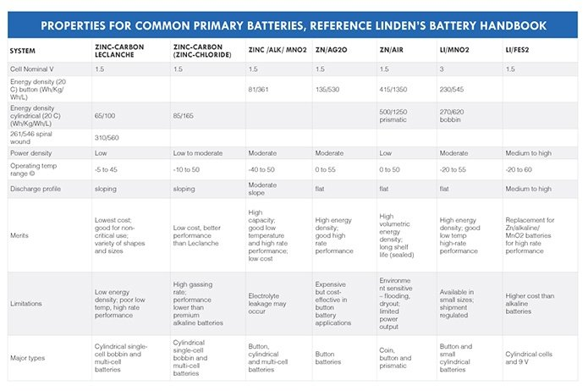

https://www.dfrsolutions.com/blog/how-to-select-the-right-battery-for-your-application-part-3-common-secondary-battery-chemistries

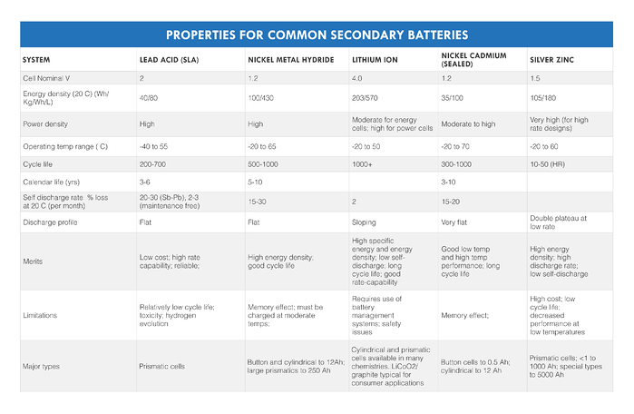

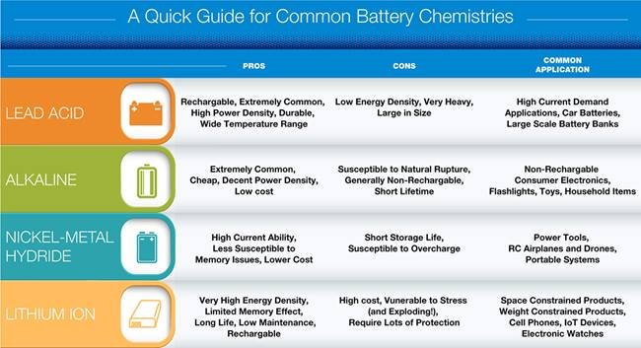

<https://www.arrow.com/en/research-and-events/articles/choosing-the-right-battery-for-your-internet-of-things-application>

<https://www.electronics-notes.com/articles/electronic_components/battery-technology/li-ion-lithium-ion-advantages-disadvantages.php>

***Protection required:***   Lithium ion cells and batteries are not as robust as some other rechargeable technologies. They require protection from being over charged and discharged too far. In addition to this, they need to have the current maintained within safe limits. Accordingly one lithium ion battery disadvantage is that they require protection circuitry incorporated to ensure they are kept within their safe operating limits.

<https://www.saftbatteries.com/energizing-iot/types-batteries-iot-devices>

### **Wireless connected objects require light and compact batteries with very high energy density and high voltage. For that reason, lithium batteries are best suited.**

panel solar

Lithium-ion batteries have become a more popular choice for solar systems all over the world. The development of this type of battery has a lot to do with its application in the electric car industry. Its prismatic form allows for ventilation and benefits use in solar systems.

Lithium-ion batteries have a unique voltage range and response to charging (two stages as opposed to the conventional three). They can be charged with a voltage regulator charge controller. Although lithium-ion batteries have a low self-discharge, they do not benefit from long-term charging.

This kind of solar battery is generally low maintenance, and has high specific energy with a long lifespan. Compared to lead-acid, lithium batteries usually cost more. In addition, they may require a protection circuit to regulate the current and voltage.

Generally, lithium-ion batteries can supply more cycles than lead-acid, making them great for delivering ancillary services to the grid. One energy-saving trait of lithium-ion, which makes it a good option for a solar system, is its high charge and discharge efficiencies. These batteries also lose less capacity when idle, which is useful in solar installations where energy is only used occasionally.

<https://werecyclesolar.com/what-kind-of-battery-is-used-for-solar-panels/>

<https://articulo.mercadolibre.com.co/MCO-479126892-panel-solar-jarrett-12w-12v-fotovoltaico-_JM#position=4&search_layout=stack&type=item&tracking_id=14b0ce80-415b-43b4-b6a5-30aa31599b64>

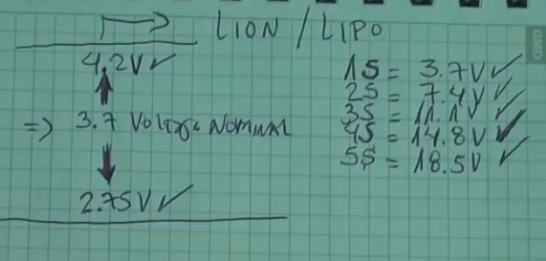

<https://www.youtube.com/watch?v=iSsDaH0SVzM>

**Regulación de voltaje**

**Regulador de 5V**

<https://components101.com/ics/7805-voltage-regulator-ic-pinout-datasheet>

The output current of this IC can go up to 1.5A. But, the IC suffers from heavy heat loss hence a Heat sink is recommended for projects that consume more current. For example if the input voltage is 12V and you are consuming 1A, then (12-5) * 1 = 7W. This 7 Watts will be dissipated as heat.

This is a typical application circuit of the 7805 IC. We just need two capacitors of vale 33uf and 0.1uf to get this IC working.

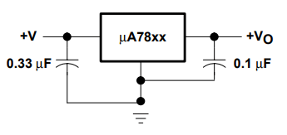

The input capacitor 0.33uF is a ceramic capacitor that deals with input inductance problem and the output capacitor 0.1uF is also a ceramic capacitor that adds to the stability of the circuit. These capacitors should be placed close to the terminals for them to work effectively. Also they should be of ceramic type, since ceramic capacitors are faster than electrolytic.

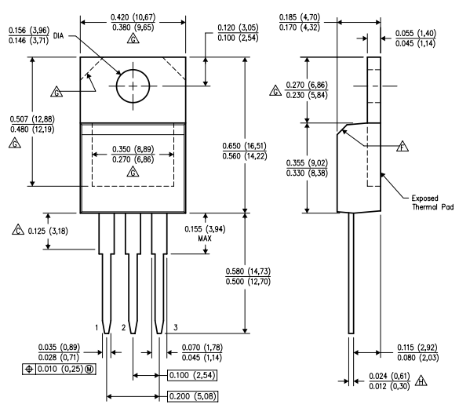

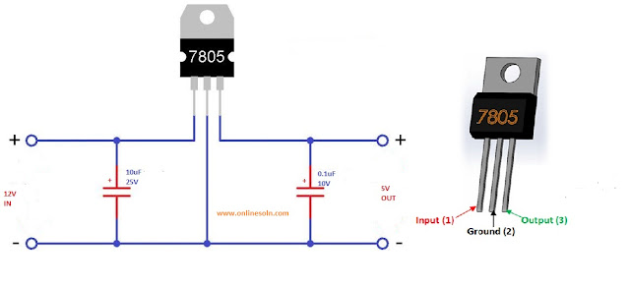

<https://www.onlinesoln.com/2020/04/converter-of-12v-to-5v-using-7805-ic.html>

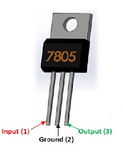

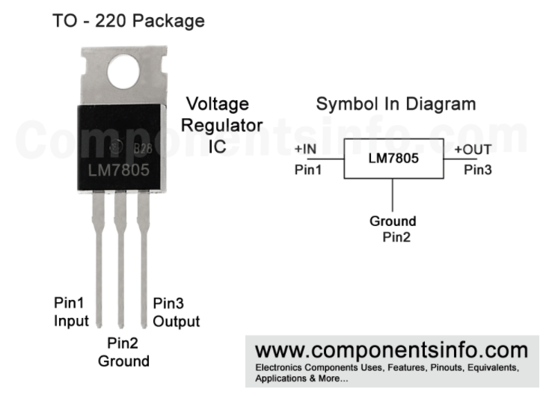

https://www.componentsinfo.com/7805-pinout-datasheet/

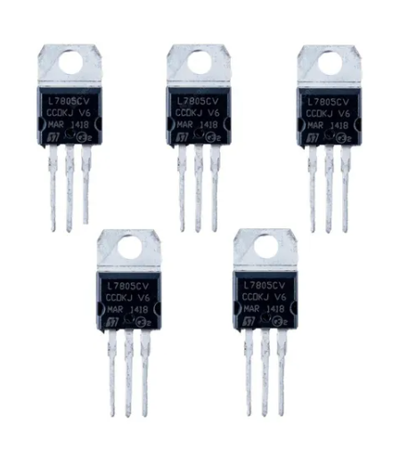

<https://articulo.mercadolibre.com.co/MCO-623384531-5-unidades-7805-regulador-voltaje-integrado-5v-positivo-_JM#reco_item_pos=0&reco_backend=machinalis-v2p&reco_backend_type=low_level&reco_client=vip-v2p&reco_id=13d7edd5-7908-4942-aca9-5e4ef4223cb3>

Buscar el disipador de calor para los 7805

**Panel solar**

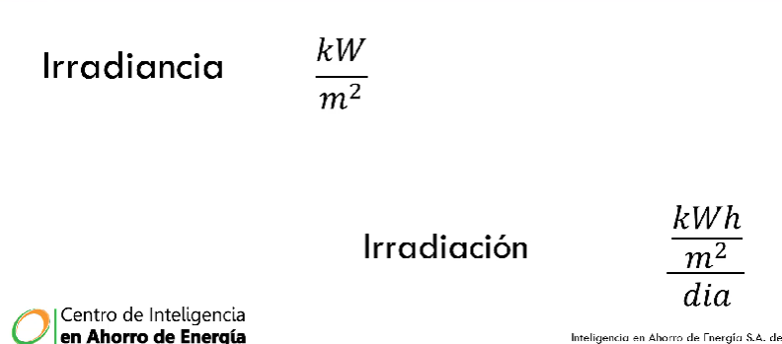

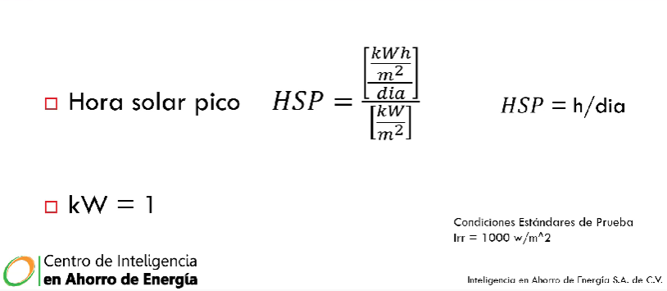

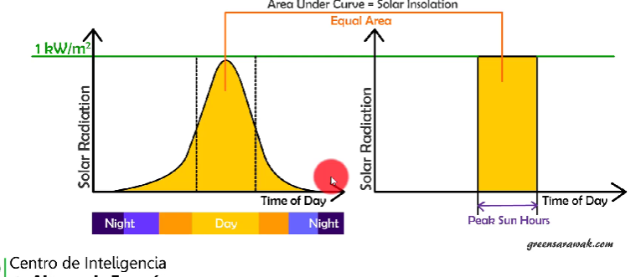

<https://es.aliexpress.com/i/4000135445771.html>

# **5X SD05CRMA 3,7 V 4,2 V Li-ion Li-Po módulo de cargador de batería de litio 5V 6V 9V 12V 18V 24V 48V 48V panel Solar**

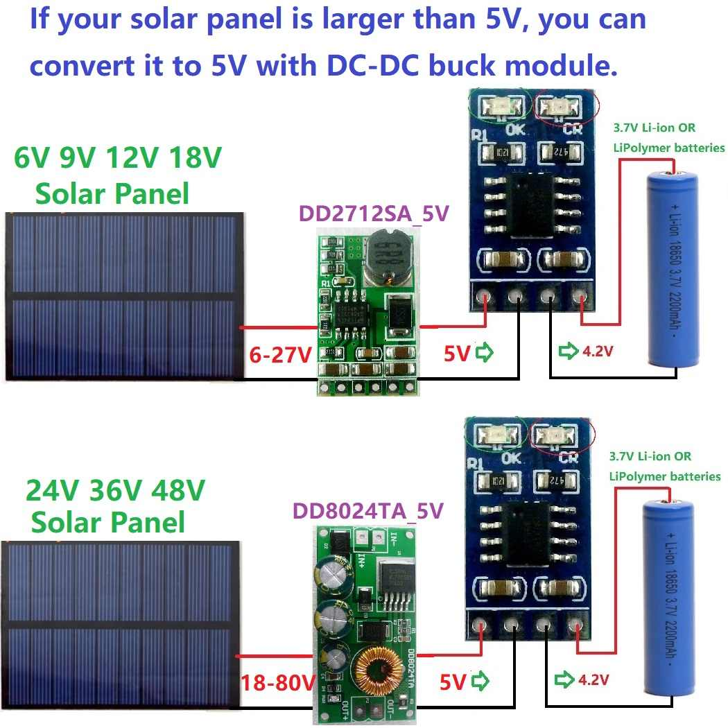

<https://forum.arduino.cc/t/alimentacion-solar-y-bateria-18650-para-arduino-uno/567057/19>

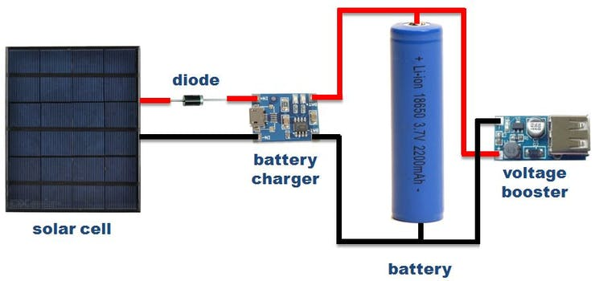

**Tiempo de vida baterías y circuito**

Autonomía de la batería

Primero calcular la potencia de la batería, luego calcular potencia de circuito por último calcular las horas. <https://www.youtube.com/watch?v=6ZMRCxyDKIk>

Vb: voltaje batería [V]

Ib: corriente batería [Ah] amperios-hora

Ic: Corriente circuito

Wb = Vb*Ib

Wc = Vb*Ic

Horas = Wb/Wc

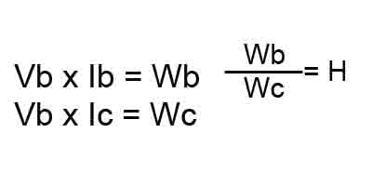

<https://coelectrix.com/calcular-la-autonomia-de-una-bateria>

Cálculo de potencia disipada por el 7805 y ajustes que se pueden hacer: <https://es.ciencia.electronica.narkive.com/57dRX7j5/7805-y-disipacion>

Tomando como ejemplo estas baterías

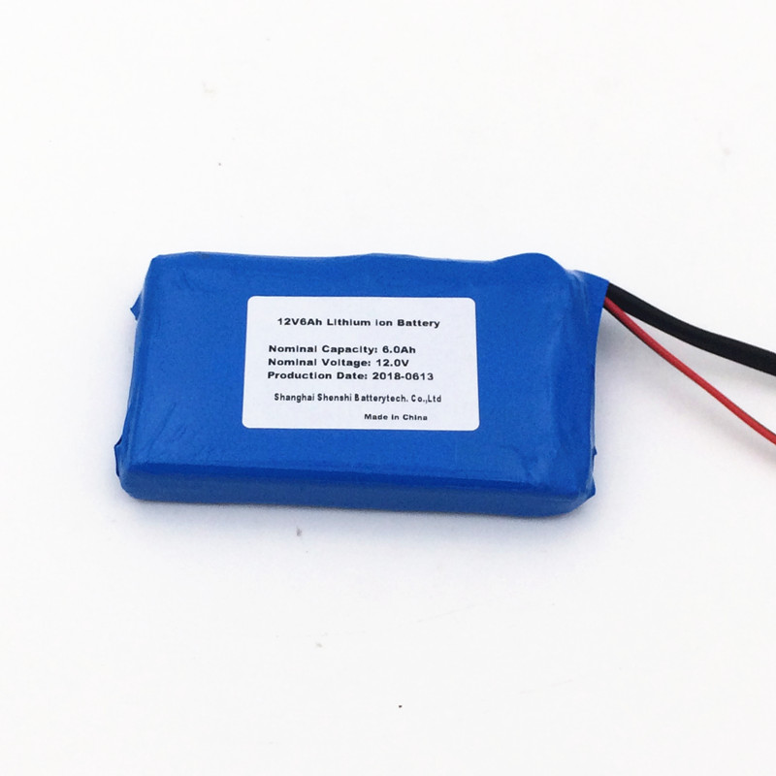

# **14.8 V 14000 mAh batería de ion de litio polímero Batería Pack en China Peluches para fuente de alimentación**

<https://www.amazon.com/-/es/14000-mAh-bater%C3%ADa-pol%C3%ADmero-Peluches-alimentaci%C3%B3n/dp/B01MEFYNFD>

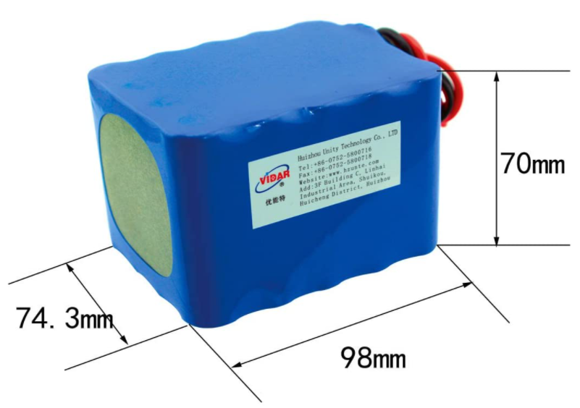

<https://articulo.mercadolibre.com.co/MCO-811159542-4pcs-14500-37v-2800mah-baterias-recargables-de-iones-de-li-_JM#position=7&search_layout=stack&type=item&tracking_id=a4ab5666-d443-40b5-8308-0f6244af8a27>

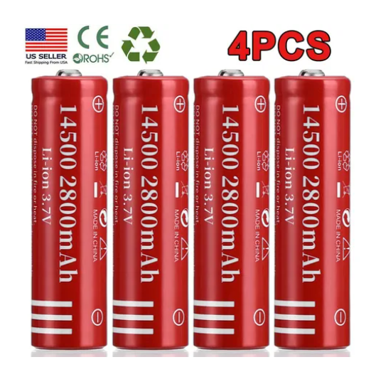

Con

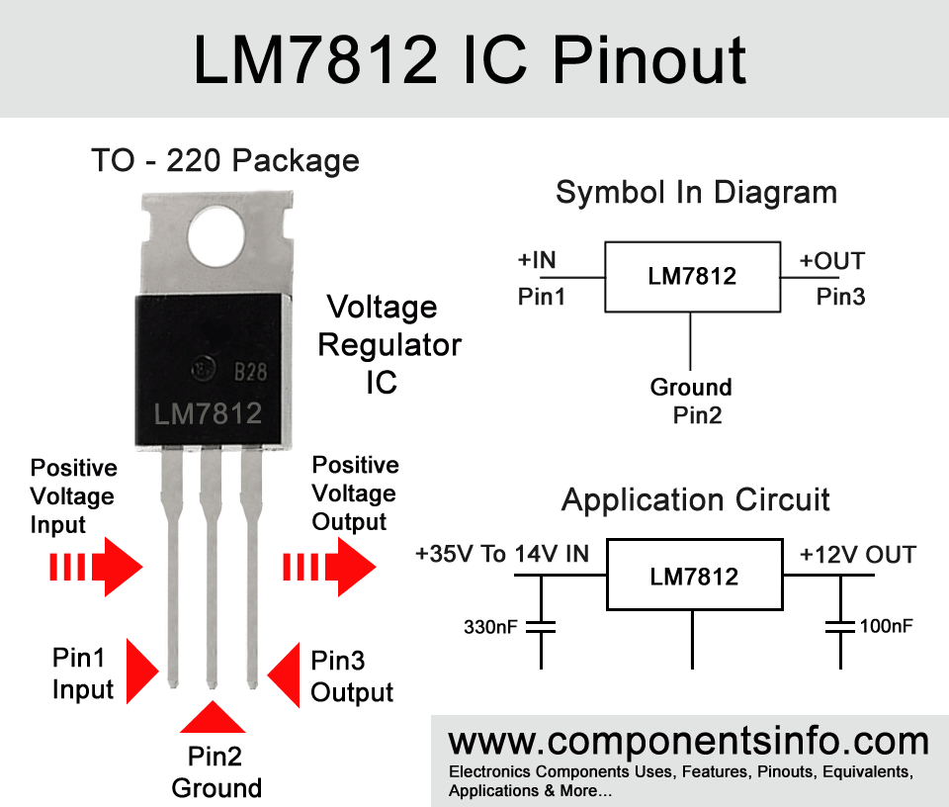

<https://www.componentsinfo.com/lm7812-pinout-equivalent/>

**consumo de energía por boya**

|  |  |  |  |  |  |  |
| --- | --- | --- | --- | --- | --- | --- |
| **componente** | **Cantidad** | **Tensión de trabajo** | **Corriente de trabajo** | **Potencia de trabajo**  **(Watt)** | **Horas de uso diario** | **Consumo diario**  **(Wh/dia)** |
| W520 | 1 | DC 5~12V +/-5% | Current <50mA | 1 W | 24 | 24 |
| W504 | 1 | DC 8-26V ±10% | Current <50mA | 1 W | 24 | 24 |
| LoRa32 ttgo | 1 | 5 V | 10 ~ 14 [mA] | 1 W | 24 | 24 |
| Módulo conversor TTL a RS485 | 2 | 5 V | 500 [uA] (máx) | 830 mW | 24 | 19,92 |
| LM7805 | 1 | 7 – 25 V de entrada* | 5 mA | De 12 a 5 V ->  (12-5)*0,005 = 0,035W | 24 | 0,84 |
| LM7812 | 1 | 14 – 35 V de entrada** | -Low standby current only 8mA  -Output current is 1.5 Ampere*** | De 14.8 a 12 V ->  (14.8-12)*0,008 = 0,0224W | 24 | 0,5376 |
| Total |  |  |  |  |  | 113,2176 |

*Se recomienda más de 7V, al menos 8 V de entrada para buen funcionamiento

**Se recomienda más de 14V, al menos 15V de entrada para buen funcionamiento

**\*\*\***the input current should be 2A to get 1A to 1.5A at the output.

Consumo diario = 93,3Wh

## Funcionamiento de panel solar

**Guia de panel solar**

<https://www.sfe-solar.com/paneles-solares/>

**Conceptos sobre baterías solares**

<https://www.sfe-solar.com/noticias/articulos/equipos-fotovoltaicos-baterias-solares-parte-iii/>

<https://www.energyavm.es/paneles-solares-cuantos-kwh-produce-un-panel-solar/>

<https://www.pcbway.com/blog/PCB_Design_Tutorial/How_to_export_a_PCB__step__from_KICAD_to_Fusion_360.html>

## Medidor de carga para baterías

## 

## 

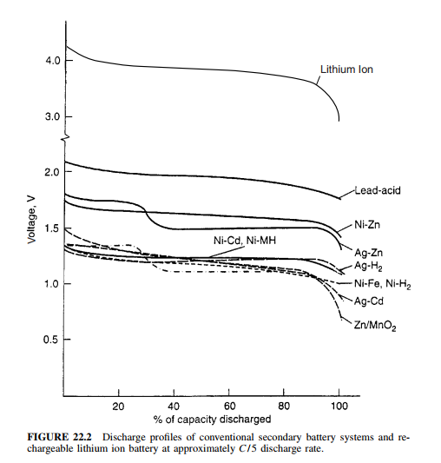

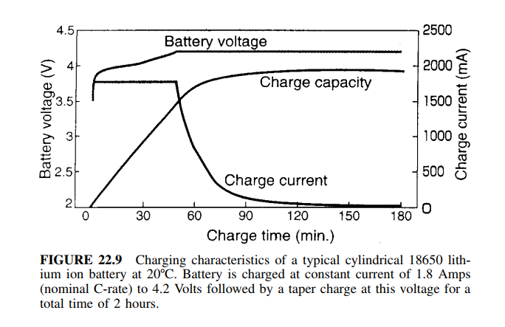

**Cosas extras**

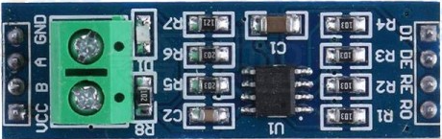

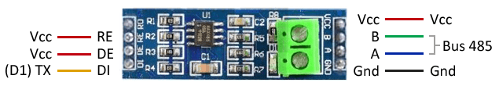

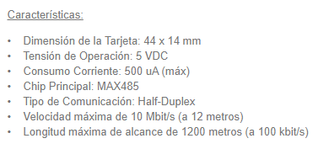

https://maxelectronica.cl/componentes-electronicos/18-modulo-conversor-serial-ttl-a-max485-rs485.html

